**HTML PROGRAM**

<html>

<head>

<title>forms</title>

</head>

<center>

<form method="post" action="feature.php">

<br>

Sign Up<br><br>

Username:<input type="text" name="username"><br><br>

Password:<input type="text" name=”passwords"><br><br>

<input type="submit" id="range" value="Submit">

</form>

</center>

</body>

</html>

**Database Connection**

<?php

$server = "localhost";

$username = "root";

$password = "";

$dbname = "login form";

$con = mysqli_connect($server, $username, $password, $dbname);

if(!$con)

{

echo "not connected";

}

$username = $_POST['username'];

$password = $_POST['password'];

$sql = "INSERT INTO `login`(`username`, `password`) VALUES ('$username','$password')";

$result = mysqli_query($con , $sql);

if($result)

{

echo "data submitted";

}

else

{

echo "query failed.....!";

}

?>

**SCREENSHOTS**

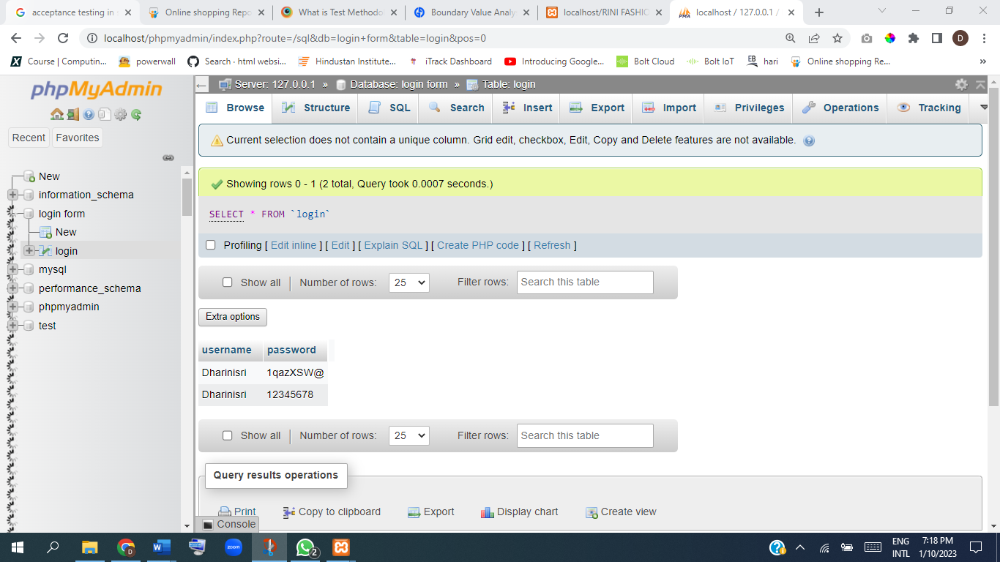**Data Base Connectivity**